Unit 8: Group Milestone - README

TEAMUP

Table of Contents

[1 Overview 1](#_Toc35362776)

[2 Product Spec 2](#_Toc35362777)

[3 Navigation 2](#_Toc35362778)

[4 Wireframes 3](#_Toc35362779)

# Overview

**Description**

Teamup is a messaging app where users can send group or private messages from their device. Users can chat with other users and share images. It’s a simple, quickly and easy way to keep in touch with co-workers or friends and family.

**App Evaluation**

* Category: Messaging App
* Mobile: This app is being developed for mobile use.
* Story: Allows user to register, login and create messages with friends on the app
* Market: The app is for any individual looking to teamup and chat with friends or coworkers
* Habit: This is a social app and can be used at the users’ discretion.
* Scope: We allow users to register and add their friends to join for conversation and file sharing.

# Product Spec

**1. User Stories (Required and Optional)**

**Required Must-have Stories**

* User can register an account
* User can create message
* User can add friends
* Add profile picture
* User can view all messages

**Optional Nice-to-have Stories**

* User can search messages
* User can change settings

**2. Screen Archetypes**

* Login
* Register – User can sign-up for an account
* Logout
* Chat Screen – Users can start a new chat and view previous chats.
* Profile Screen – Allow users to update info and pictures.

# Navigation

**Tab Navigation** (Tab to Screen)

* Friends
* Groups
* Posts
* Logout

**Flow Navigation** (Screen to Screen)

* Splash/Signup
* Create Account
* Login
  + Home Screen
* Groups
  + Create Group
  + View Groups
  + Remove Group
* Friends
  + View Friends
  + Add Friends
  + Remove Friends

# Wireframes

[–––––](https://github.com/JavaTeamUp/MessageApp/blob/master/sketch.JPG)

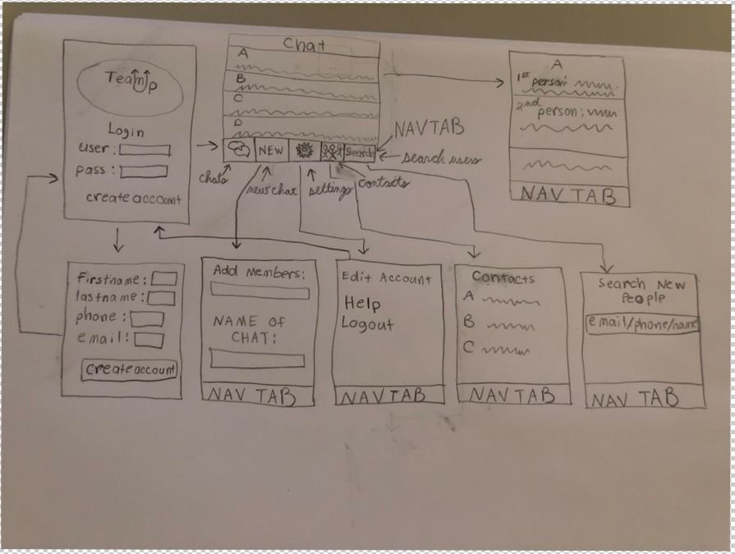

[BONUS] Digital Wireframes & Mockups

|  |  |  |
| --- | --- | --- |
|  |  |  |
|  |  |  |

[BONUS] Interactive Prototype

[https://xd.adobe.com/view/3db362f6-d2cf-4ab6-4b15-ee52237a18a3-4b82/](https://xd.adobe.com/view/3db362f6-d2cf-4ab6-4b15-ee52237a18a3-4b82/" \t "_blank)

## Schema

[This section will be completed in Unit 9]

### Models

[Add table of models]

### Networking

- [Add list of network requests by screen ]

- [Create basic snippets for each Parse network request]

- [OPTIONAL: List endpoints if using existing API such as Yelp]